St Barnabas, Pasadena

The Stations of the Cross

Meditations and prayers based on ones by Mother Mary Angelica of the Annunciation, an American Franciscan nun

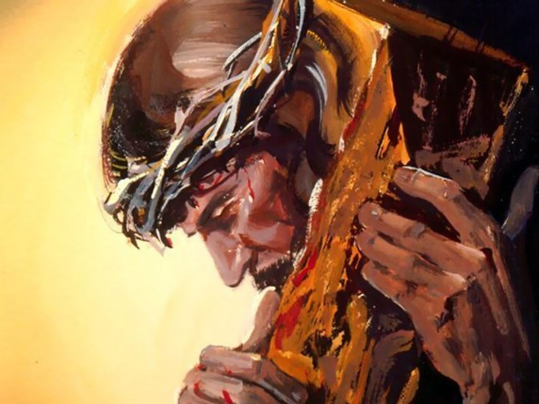

The Thirteenth Station: Jesus is Taken Down From the Cross
Mary finally took you into her arms and saw close up the wounds that had been inflicted on you. Mary Magdalene looked at your tortured body with horror. Nicodemus and Joseph of Arimathea gained the courage to take your body down. Here is the great act of love, achieved in desolation and humiliation, recognized by only one or two, yet at least recognized by one or two.

The Fourteenth Station: Jesus is Laid in the Tomb
Jesus, you had no room of your own in which to be born and you had no tomb of your own in which to be laid to rest. When you were born angels sang; now you are dead and creation is silent. Most of us are born in obscurity and die in obscurity, known by only a few in our living and our dying. But we commit ourselves, as you did, to living and dying by our Father’s will.

The Tenth Station: Jesus is Stripped of His Garments

Every step to Calvary brought fresh humiliation. You were made to leave this world almost as naked as you entered it, and you submitted to doing so. I imagine you looking up to your Father in the context of the cold and shame and trembling and asking for the forgiveness of people who treated you in the way they do, concerned only to gain a share in some stuff.

The Eleventh Station: Jesus is Nailed to the Cross
It’s hard to imagine the Son of God being nailed to a cross by human beings—to imagine God being executed by people he created. As they hammered the nails into your hands, I know you were making your acceptance of that treatment into an offering you made to God to make reparation for the way we drive nails into one another and into God.

The Twelfth Station: Jesus Dies on the Cross
The Son of God dies! No wonder the earth quakes, the sun hides, dead people come out of their tombs. Creation itself rebels at the idea that the Son of God dies. One thief ridicules what is happening, but another recognizes it, owns his guilt but sees your innocence and turns to you. Now we have before us the ultimate expression of how far God is prepared to go for us.

The First Station: Jesus is Condemned to Death
Jesus, the world puts you on trial, and so do we. Why are things the way they are in the world? Why don’t you make them different? Why are things the way they are in my life? Why don’t you put them right? Thank you for your steadfastness in the face of accusation and for your trust in your Father. Give us grace to follow you in your poise and silence.

The Second Station: Jesus Carries His Cross
How could we have made you carry your cross? How did you keep resentment from welling up in your heart? How did you stop yourself rebelling and walking away from this destiny? How did you avoid being frustrated by people’s unwillingness to see the truth about God and about you? How did you hold hack from resentment and rejection of them?

The Third Station: Jesus Falls the First Time
Jesus, I would have expected you to carry your cross without stumbling, without falling, without faltering. Your faltering brings home how fully human you are. You acknowledge that your cross was a heavy burden. Carrying it was not easy because you were the Son of God. Your stumbling encourages me, because I stumble, too. I stumble not just once or twice or three times, but more.

The Fourth Station: Jesus Meets His Afflicted Mother
What went on between you? How could she bear what was happening to her son? How did you both have the courage to carry on? Do you both have to give your suffering to your Father, for the sake of the world’s salvation? I pray for mothers who go through excruciating pain as they see their children suffer, and for children who go through excruciating pain as they see their parents suffer.

The Fifth Station: Simon Helps Jesus Carry His Cross
I wonder what Simon thought about carrying your cross? Was he reluctant? How did he react to the jeers? Did he wonder why he was chosen for this tough task? Was it by design that a man was chosen who could become a symbol of prejudice on the basis of race and color and creed? Thank you for inspiring him to accept it. Give me the strength to take up the cross and follow you.

The Sixth Station: Veronica Wipes the Face of Jesus
Where were the hundreds of people whose bodies and spirits you healed? Did you think about their forgetfulness and their carelessness? Did you think about how their attitudes had changed? Here is one person who ignored fear and people’s possible scorn and broke from the crowd to offer you her thin veil to wipe your bleeding face. She did not care if the whole world knew of her care for you.

The Seventh Station: Jesus Falls A Second Time
Jesus, you were strong when people laughed at you. Now you look weak. Yet I know that this appearance is deceptive. You will be strong enough to continue. Give me the grace to see beyond what is visible and know there can be abiding strength even where there is apparent weakness or weakness for a moment.

The Eighth Station: Jesus Speaks to the Holy Women
Even as you stumbled towards the place of execution, you maintained the compassion that had characterized your entire life. You taught the women of Jerusalem to look deeper into your suffering, to understand that the real evil to cry over was the fact that the chosen people had rejected you. Your act of redemption would go on, but the greed and jealousy and ambition of people would hinder their recognizing it.

The Ninth Station: Jesus Falls the Third Time
You fell three times? Are you reassuring me that I am not alone if I fall three times? There may be times in my life when the cross I take up is impossible to bear. Now I know that when I cry out, “This is more than I can cope with,” you are in a position to say, “I know, and I know it’s hard to get back up.” And I pray for other people who have fallen, and fallen again, and fallen again, and ask you to reach out to them.

